Website Proposal by: [John Paul Denaya](mailto:24104968@usc.edu.ph)

# **Website Name:**

* JPDwonders: Curiosity Meets Excellence

# **Concept of the Website:**

* A clean, minimalistic website that focuses on showcasing portfolios and projects with a sleek, modern design.
* The website will emphasize simplicity, ease of navigation, and a clutter-free user experience.

# **Purpose of the Website:**

* The website will gather all the topics from the first semester and put them together in one easy-to-use place.
* It covers everything from computer science as a field to computer software and hardware, and the different types of computers, all in an easy-to-navigate website.
* It will organize all the PowerPoints and documents into a user-friendly site that serves as both a study tool and a display of my learning progress.

# **Target Audience:**

* The website is for students and anyone curious about learning more about Introduction to Computing (ITC) topics.

# **Wireframes:**

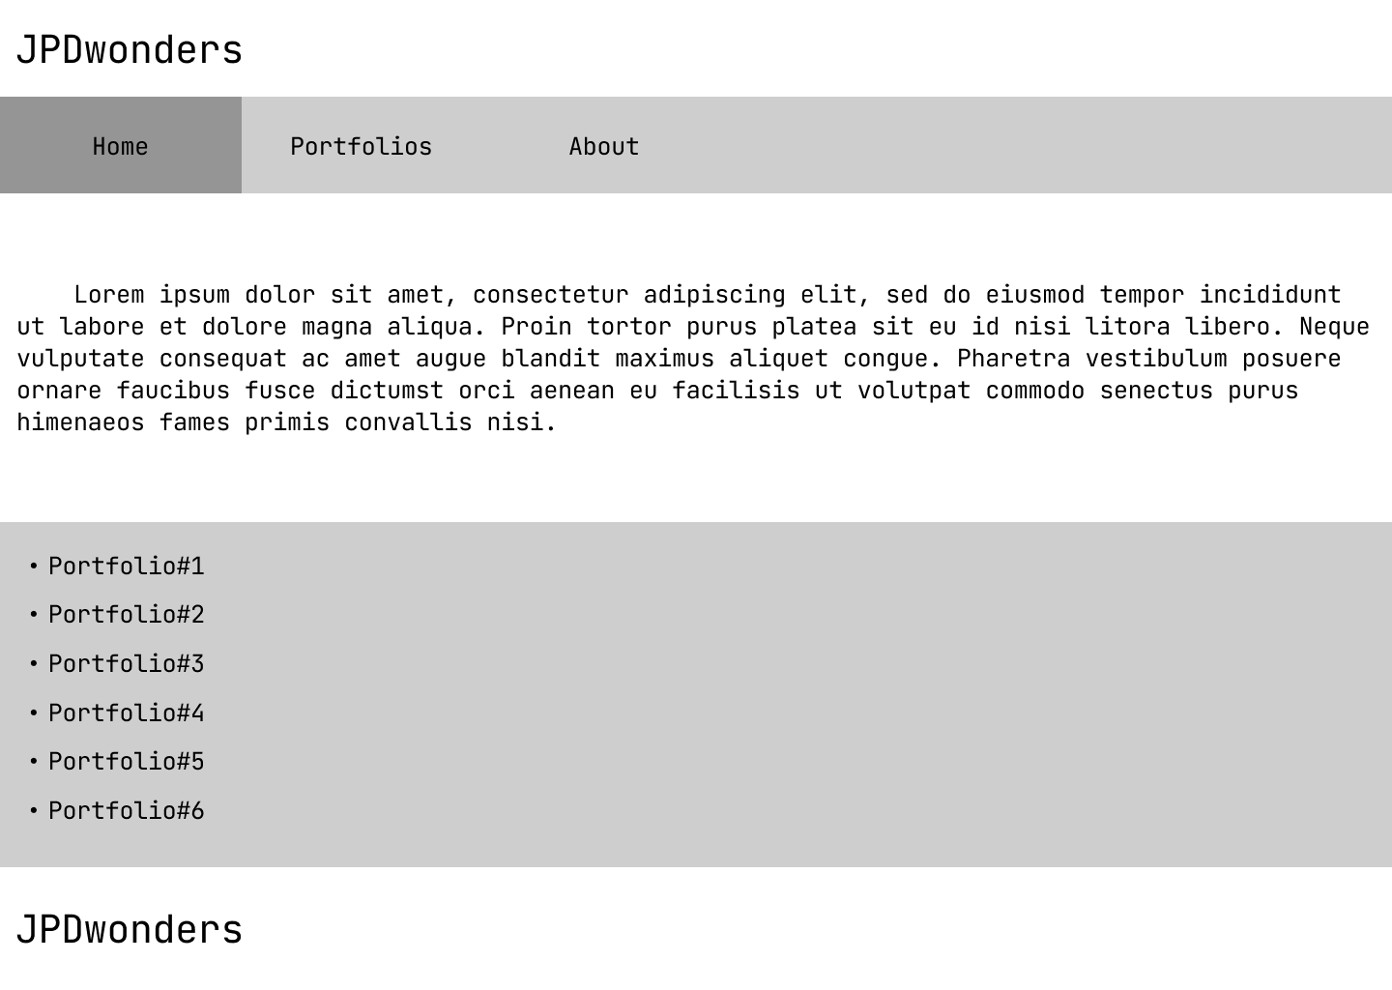

*Figure 1.0.*

## **Home Page:**

* The first page that the users will interact with is the home page.
* At the very top, the header will be a hyperlink that directs to the home page.
* At the very bottom, the footer will be a hyperlink that directs to the about page.
* Below the header is the navigation bar, where the users can use to navigate the website.
* Below the navigation bar is a paragraph about what the website is all about
* Above the footer are hyperlinks to the page of each portfolios

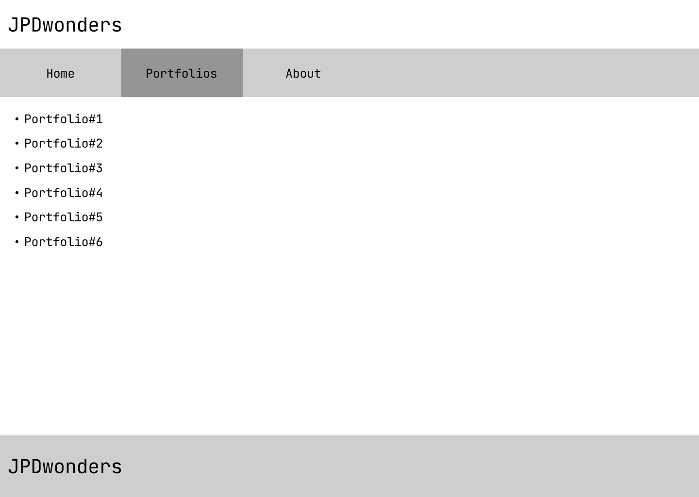

*Figure 2.1.*

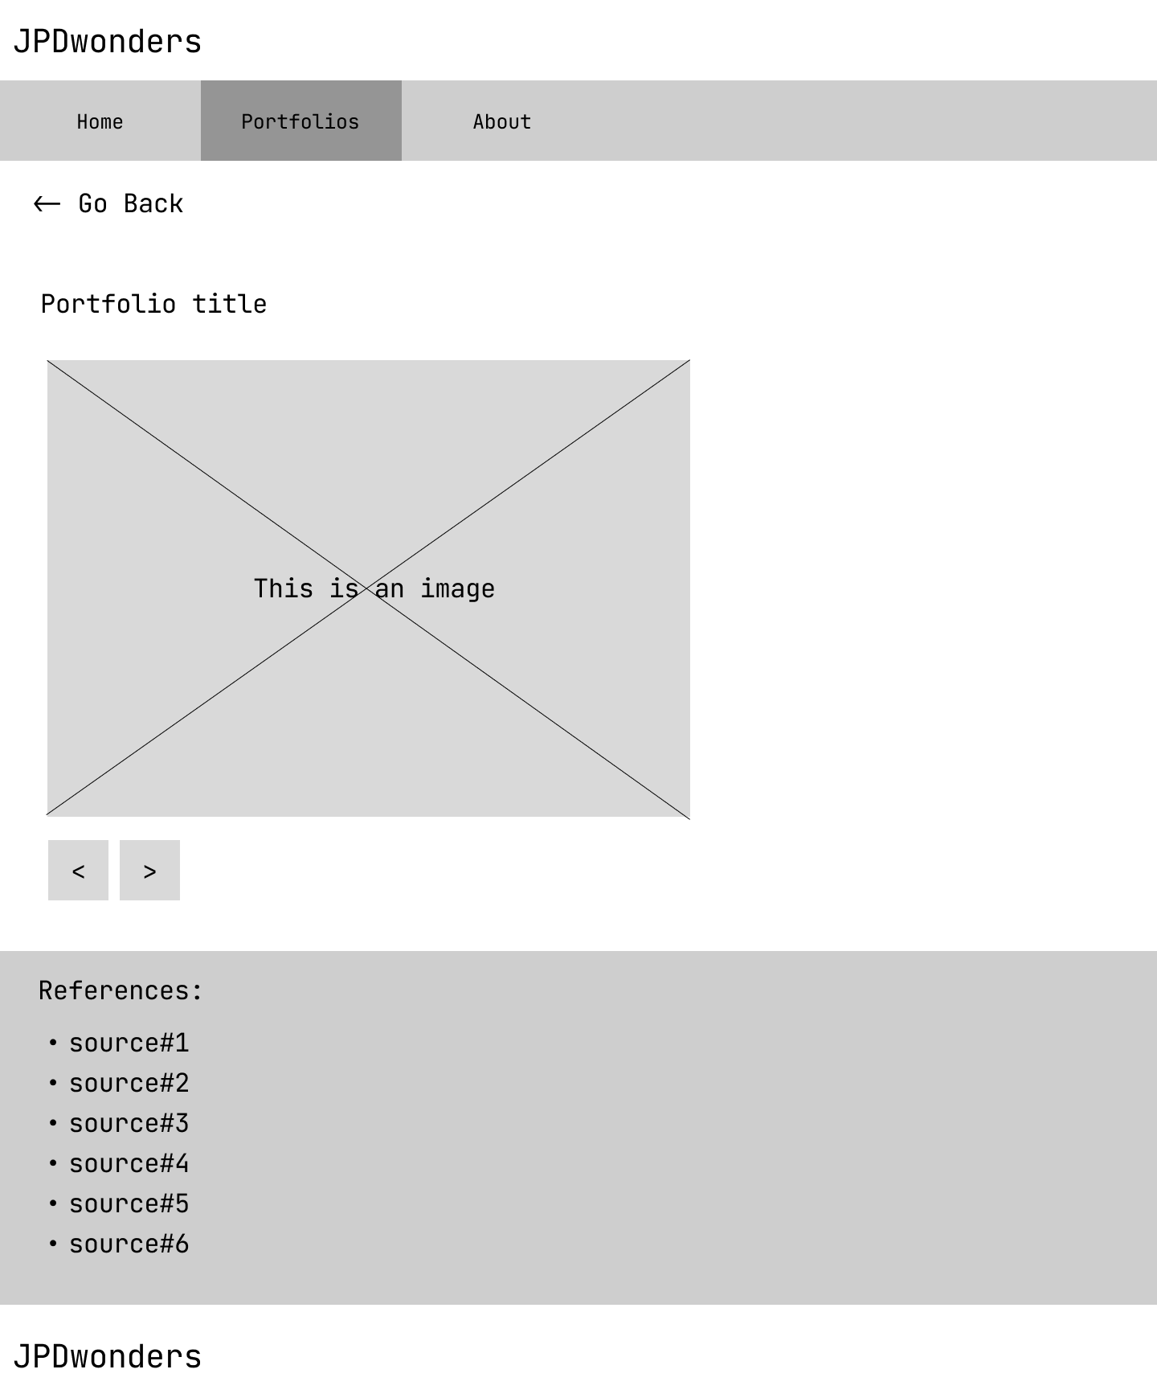

*Figure 2.2.*

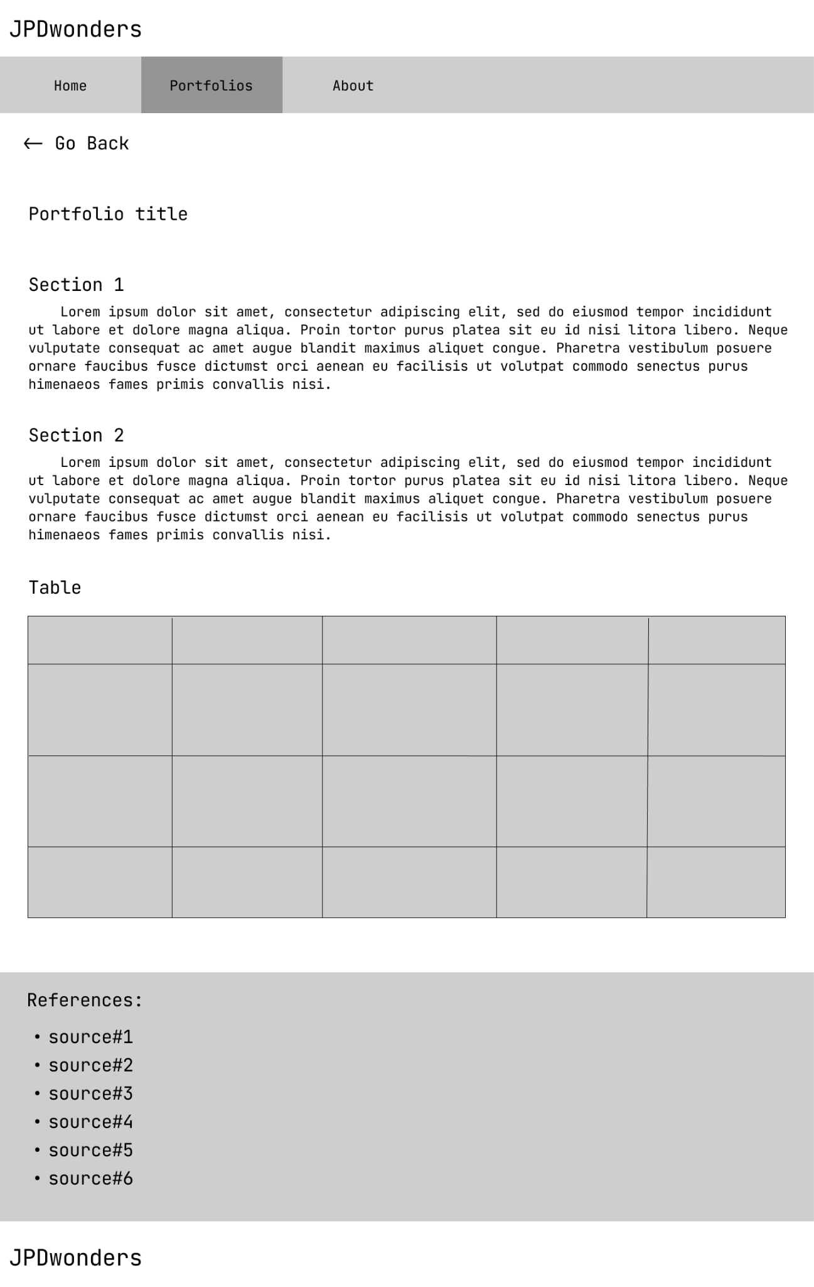

*Figure 2.3.*

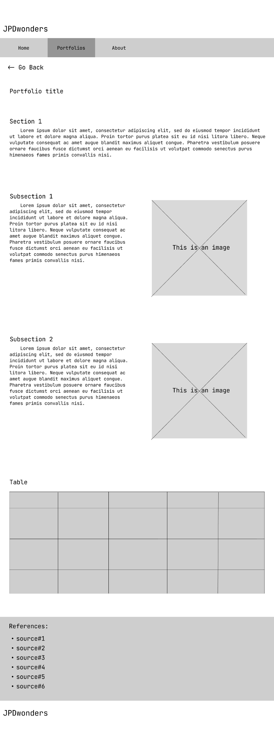

*Figure 2.4.*

## 

## **Portfolios Page:**

* Figure 2.1:
  + The hyperlink in the navigation bar with the text “Portfolios” directs to this page.
  + Similar to the home page, this page would also have the same header, navigation bar, and footer.
  + The main contents of this page are hyperlinks to the page of each portfolio.
* Figure 2.2:
  + The page for portfolio 1 - 4 will have the same layout.
  + Similar to the home page, this page would also have the same header, navigation bar, and footer.
  + Under the navigation bar is a hyperlink that directs to the portfolios page which is shown in figure 2.1.
  + Above the footer is the references section.
  + Above the reference section are two buttons that can be used to move to the next slide/image that is shown above the buttons.
* Figure 2.3:
  + This will be the layout for portfolio #5.
  + Similar to figure 2.2, this page would also have the same header, navigation bar, “Go Back” hyperlink, references section, and footer.
  + This page will contain some sections with discussions.
  + Above the reference section, there will be a table section.
* Figure 2.4:
  + This will be the layout for portfolio #6.
  + Similar to figure 2.2, this page would also have the same header, navigation bar, “Go Back” hyperlink, sections with discussions, table section, references section, and footer.
  + Some sections with discussions will have a subsection that includes an image and a discussion section.

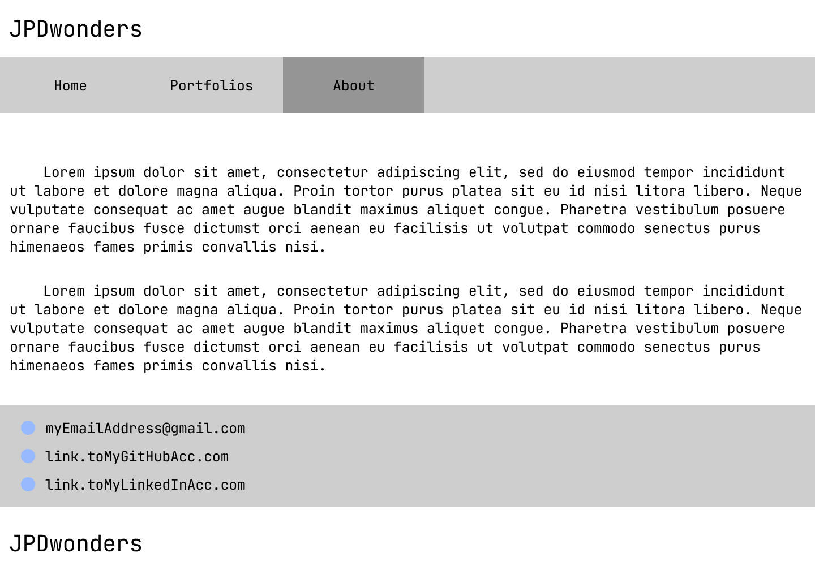

*Figure 3.0.*

## **About Page:**

* Similar to the home page, this page will also have the same header, navigation bar, and footer.
* The main content of this page is an autobiography of [John Paul Denaya](mailto:24104968@usc.edu.ph)
* Above the footer are hyperlinks to [John Paul Denaya](mailto:24104968@usc.edu.ph)’s social media pages.

# **Website Project Management:**